APCS 350 Data Structures Project Spring 2015

Walkthroughs
There will be 2 Walkthroughs
- an Analysis Walkthrough on April 8th in class
- a Design Walkthrough on April 15th in class

Final Deliverables for April 27
- UML Class Diagram for each class used (including any data structures that aren’t C++ std)
- Your source code (all non- C++ std files)
- Printout of output file from a sample run
- Completed test plan
- Completed project plan
- 2 Completed Walkthrough forms

The Project

Intro
A small hospital wants to automate its scheduling services. You have been assigned to design the initial version of the schedules. The basic functions that the hospital has in mind are doctor check-in and check-out and patient check-in and check-out.
A doctor checks in by telling the scheduler his or her name, an examination room number, and a medical specialty code. Each doctor has a favorite room. The scheduler checks to see whether the room is free. If so, it assigns this doctor to the room; if not, it rejects the request with a message, and the doctor can try again to check in. When a doctor checks out, the examination room is freed.
A patient checking in gives a name, age, and specialist code. The scheduler tries to match up the patient with a doctor according to a set of rules that are described here. If there is a match, the patient is seen by the assigned doctor. If this doctor is currently seeing a patient, the new patient is queued to see the doctor.
The rules for assigning doctors to patients are as follows:
l. Any patient under age 15 is assigned to see a pediatrician.
2. Patients age 15 and older are assigned a doctor according to the specialty requested. If there is no doctor in the hospital with the requested specialty, the patient is assigned to a family practitioner (FP). If there is no FP currently in the hospital, the patient can be assigned to any doctor.
3. If there is more than one doctor of the requested specialty, the patient is assigned to the doctor with the shortest waiting list.
When a patient checks out, the doctor to whom he or she was assigned is available to see the next patient if there is anyone in the waiting list.

Input
Because this is an interactive system (but not a GUI), your program should prompt the users to input the correct information. The initial prompt is
' Type D for Doctor or P for Patient: '

The next prompt is
Type I for check-in or O for checkout:

According to the request, your program should prompt the user for any other needed information, as indicated in the following table:

Action | Additional Information
Doctor check-in  Doctor check-out  Patient check-in  Patient check-out | Doctor's name  Room number  Specialty code  Doctor's name  Patient's name  Age  Specialty (code requested)  Patient's name  Room number

You may define the format for the input processed by your program, but be sure to make it “user-friendly”.

Output
The output for each request is in the form of messages to the user, according to the request, as indicated in the following table.
Action | Message
Doctor check-in  Doctor check-out  Patient check-in  Patient check-out | Confirmation that room is available or Error message if room is in use.  Good-bye message  Message telling patient which room to go to and which doctor has been assigned.  If no doctor is available, apologetic message.  Good-bye message. At a later time we may add billing information at this point.

In addition to printing the messages on the screen, you should also write the requests and messages to a transaction file (messages.out), for a given date. This date may be obtained from the system date or by prompting the hospital IT person to enter the date when the system is started each morning.

Details and Assumptions
1. There are 25 examination rooms at the hospital, each with a waiting room attached.
2. Specialty codes are as follows:
Pediatrics PED
Family practice FAM
Internal medicine INT
Cardiology CAR
Surgeon SUR
Obstetrics OBS
Psychiatry PSY
Neurology NEU
Orthopedics ORT
Dermatology DET
Ophthalmology OPT
Ear, Nose, and Throat ENT
3. You may assume that no patient leaves without checking out. (That is, every doctor becomes free eventually.)
4. No one leaves before he or she sees a doctor. (That is, no one has to be taken out of the waiting queue.) The hospital will stay open until all patients are seen.
5. If a doctor checks out while there is still a waiting list of patients assigned to him or her, the patients must be reassigned to other doctors.

Data Structures
The basic data structure needs to track examination rooms, each of which has a waiting list.

Example Class Diagram

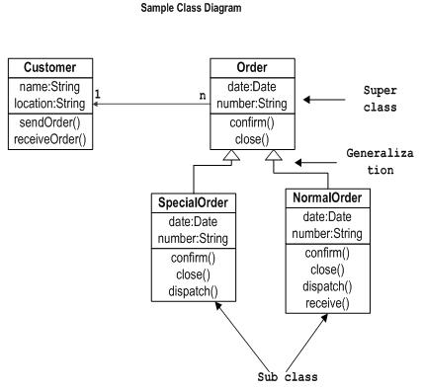

Grading Form

Completed Walkthrough Forms up to 2 pts _____
Class Diagram(s) up to 5 pts _____
Project implemented and compiles up to 8 pts _____
Project produces screen & file output up to 8 pts _____
Project produces correct output up to 7 pts _____
Completed Test Plan up to 5 pts _____
Good Prompts, Output Formatting,
Programming Style/Structure up to 5 pts _____

Project Plan

As you get to each phase of the project shown below, please write a brief description of what you plan to do.

Analyzing (What is the project supposed to do?) – Write a list of requirements

Designing (How can the program be designed do it?) – Describe the classes you intend to create/use

Coding (Translate the design into C++ code and implement it) – Describe your planned coding environment (IDE, source code repository, etc.)

Testing & Debugging (Is it right? Correcting & modifying) – Describe how you will approach testing, and how you will fix any bugs discovered in testing

Documenting (How others will know how to use your program and code) – Describe your planned documentation for the project (including comments in the code)

Project Walkthrough

Name __________________________________________________ Date __________________

Add a Checkmark to the Items Available for Inspection at Walkthrough
Project Plan ______

Class/Function Specifications _____

Data Structure Specifications _____

Test Plan with data ______

I certify that I have listened to the above-named programmer explain his/her plan for this project, have examined all available documentation, and have offered my best counsel.

Signed Comments (on quality, completeness, etc.)

Test Plan

Test case |  | Parameters  Data values | Expected result | Checked

